# Object Types: Varray and Table Collections

* Object Types
  + Varray Collections:
    - Single-dimensional
    - Has size limit
    - By default allow NULL
    - Elements are all the same data type
    - Both varray and Table data types have three possible states:
      * NULL
      * Empty
      * Populated
    - Use this when the number of elements is known, the elements need to be accessed in order or the order needs to be guaranteed
    - Example:

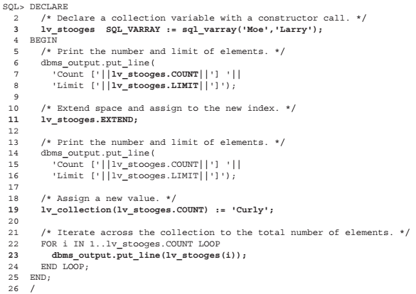

* + Table Collections
    - Single-dimensional structure
    - No limits (except database resources)
    - Must have same data type
    - Default allows NULL
    - When using Attribute Data Type (ADT) collection must use PL/SQL to update or add an element
    - You want to use a table collection when a number of elements is unknown, when the number of order is unknown
    - Example:

